**Lecture 38,39: Versioning Restful Service:**

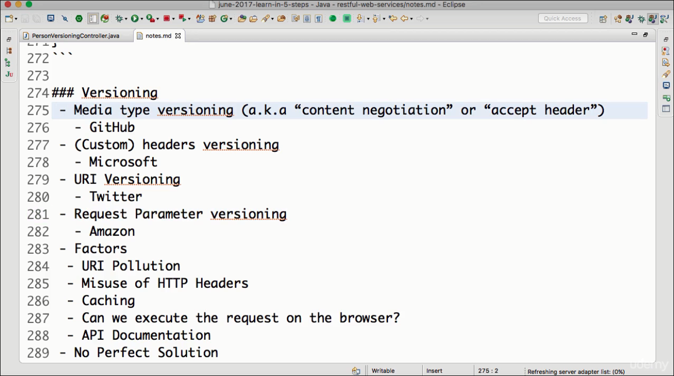

**→ URI Versioning**

**→ Header Versioning**

**→ Request Param versioning**

**→ MIME type versioning**

**1 & 2 → pollutes URIs** ( many URIs for the same functionality)

**3 & 4 → pollutes Headers** ( Many headers that are not intended for versioning are used) .Caching becomes difficult here.

**Disadv:**

**URI pollution → happens in 1**

**Header Pollution→ happens 2**

**Caching → not easy in 3,4**

**Ease of executing request on browser → not easy in 3,4**

**Ease of generating documentation → easy in 1 & 2**

**\*\* before coding , finalize your versioning strategy**

**URI-Approach1: ( URI versioning)**

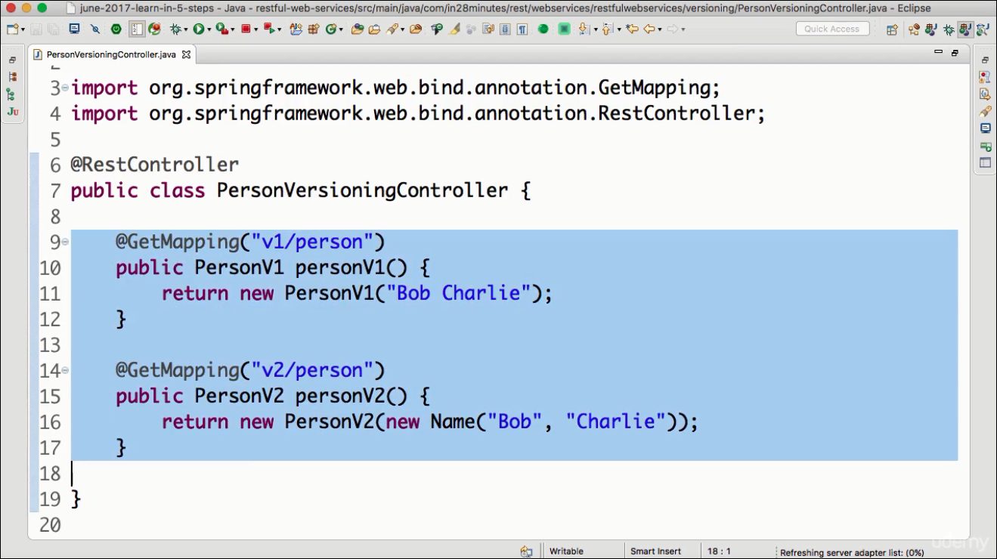

**URI-Approach2: ( request params versioning)**

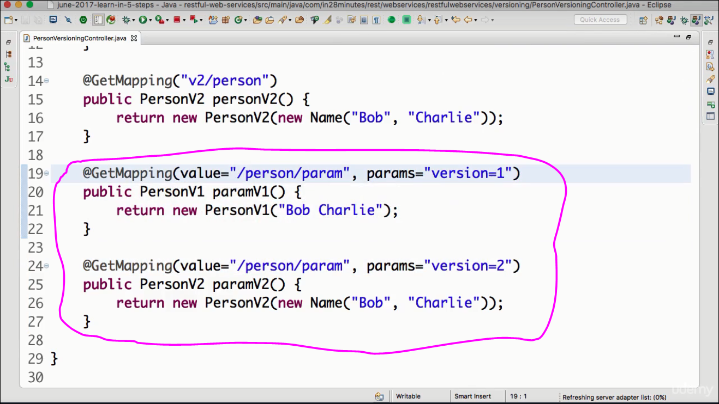

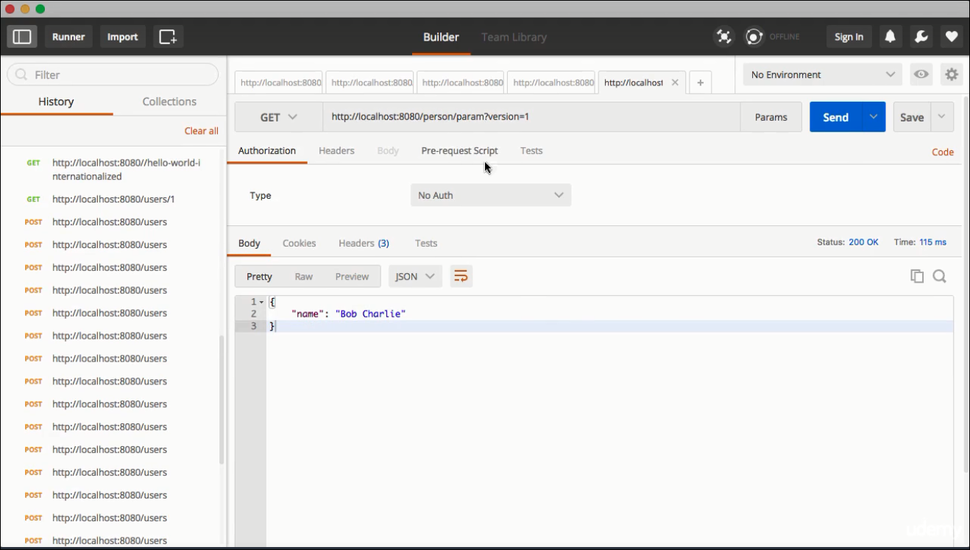

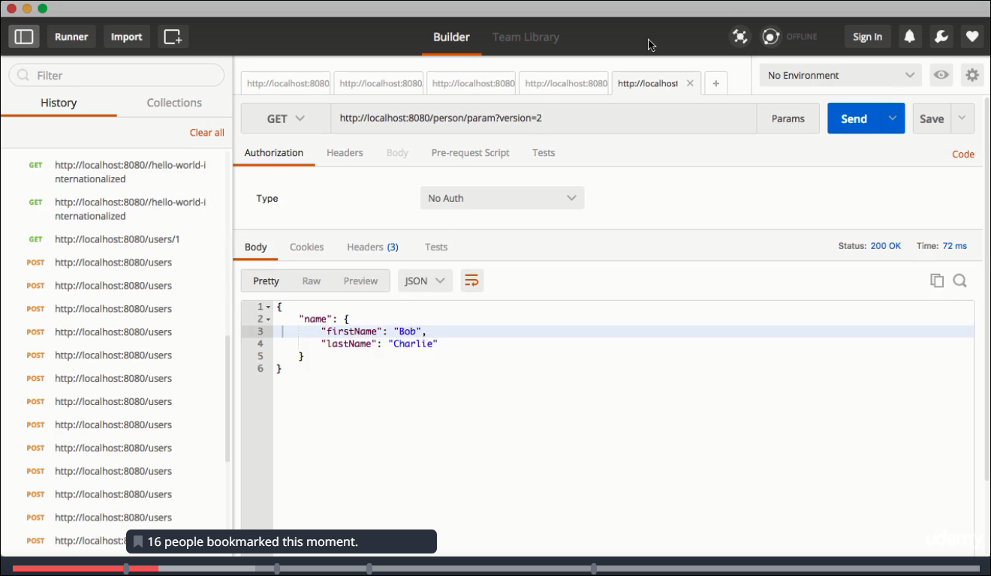

**Approach 3 : using header**

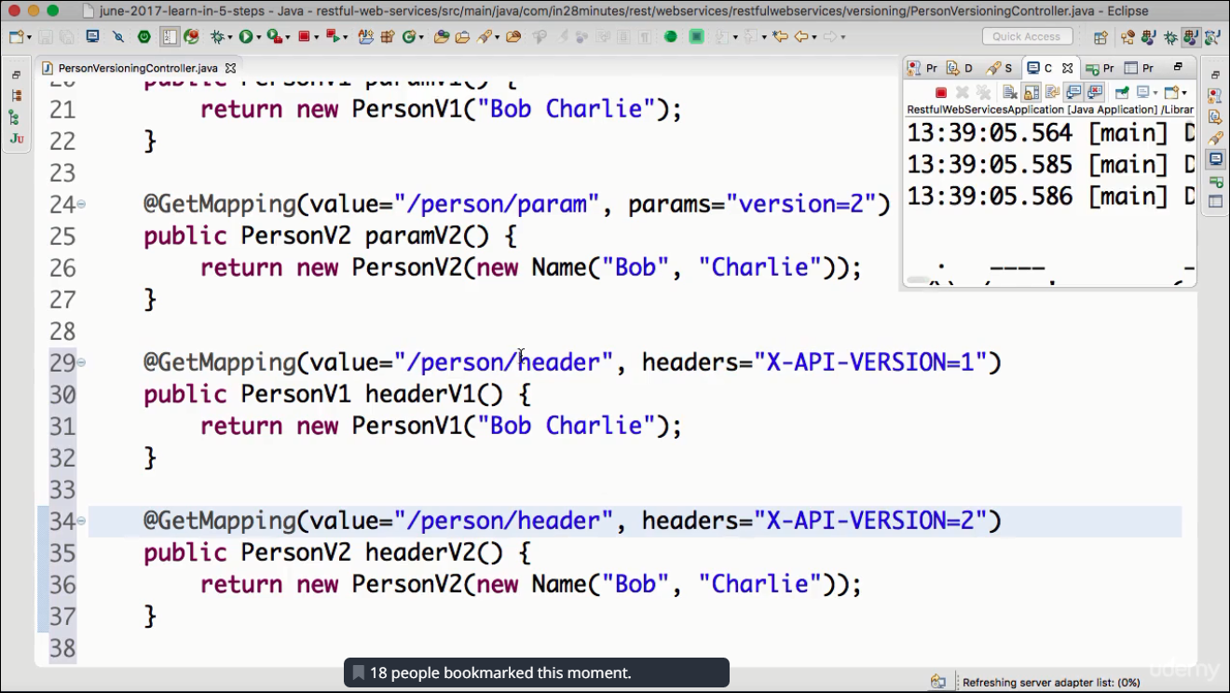

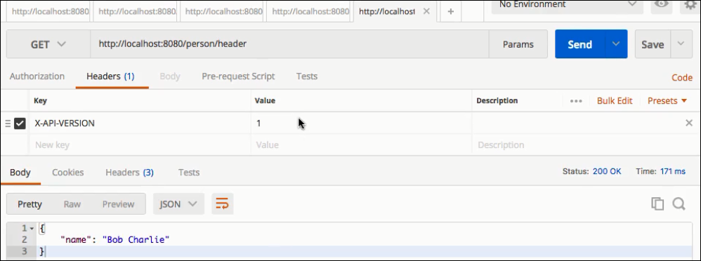

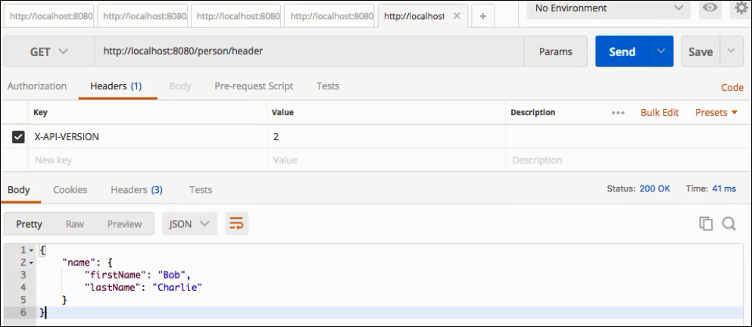

**Approach4: (MIME type versioning)** using return type( produces)

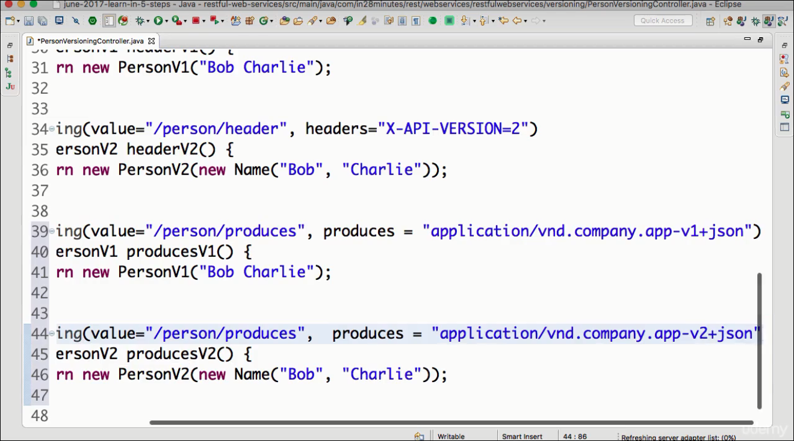

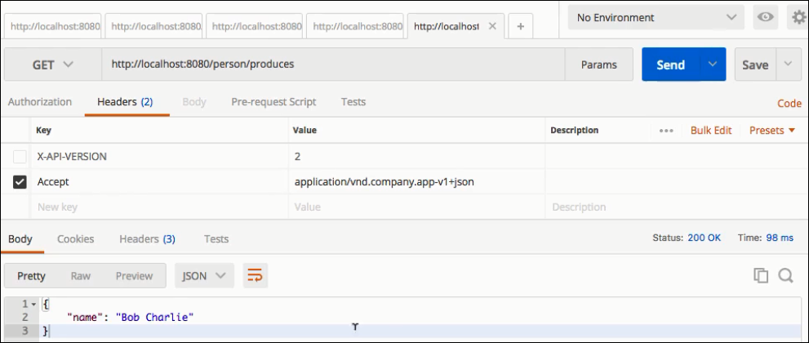

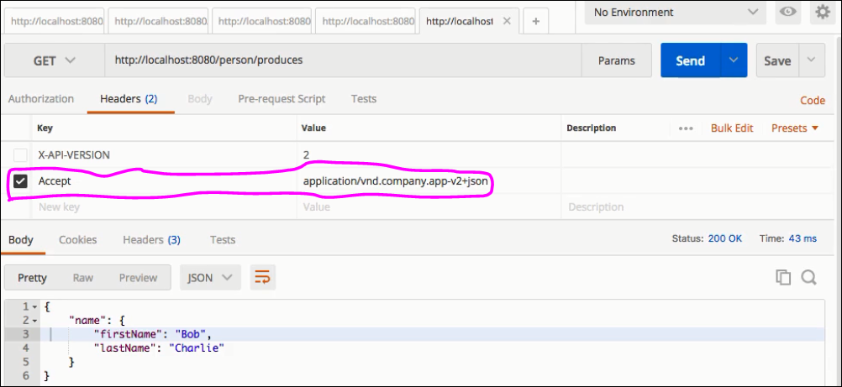

**Lecture 40: Basic Authentication**

Step1:

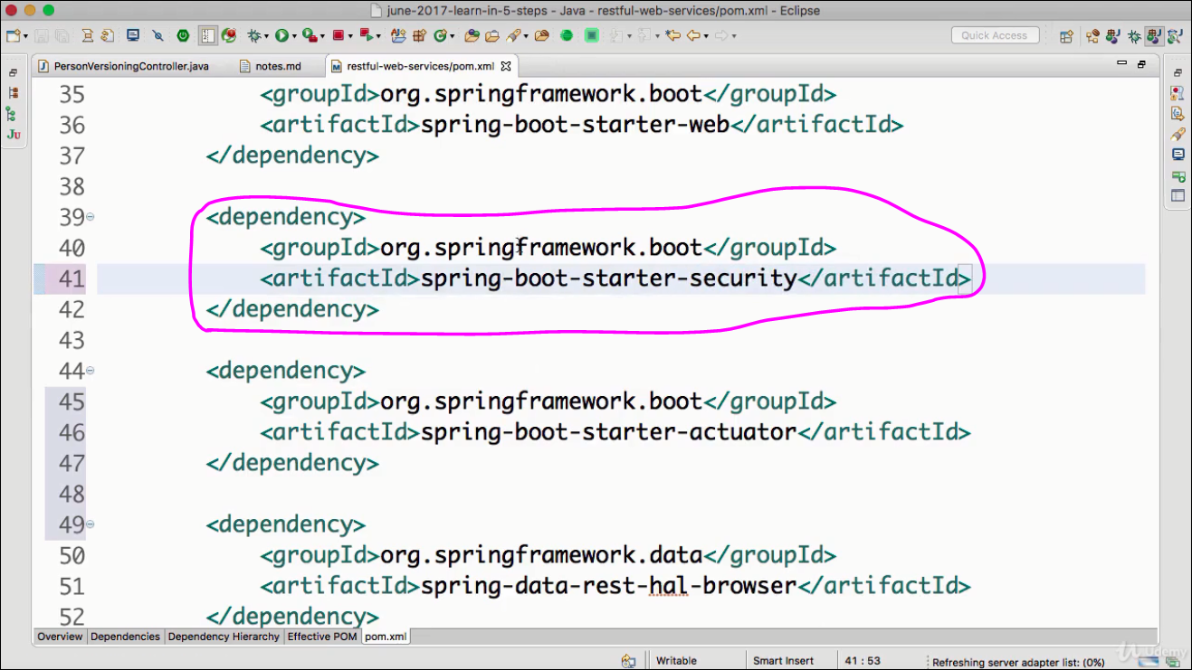

Step2: Restart the server . U will notice the default password in the log.copy it.

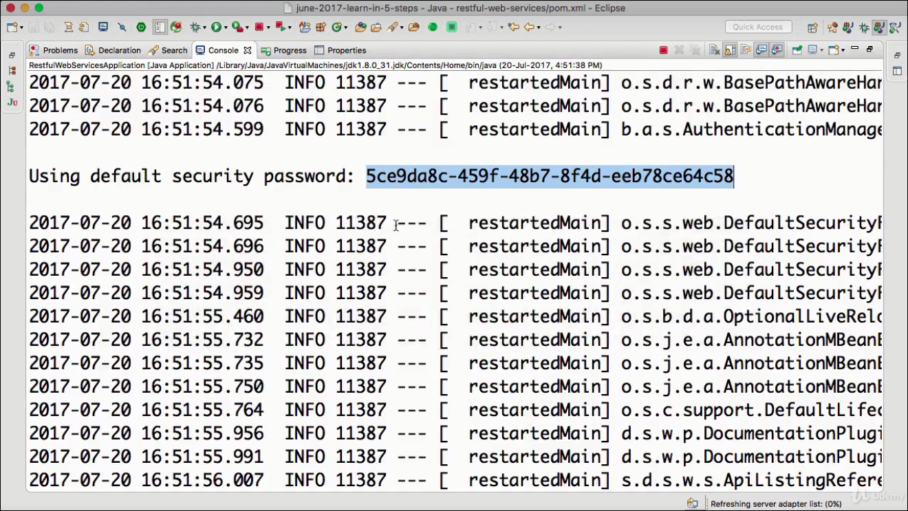

Now use the same password & default user “user” in the request to access alll the resources.

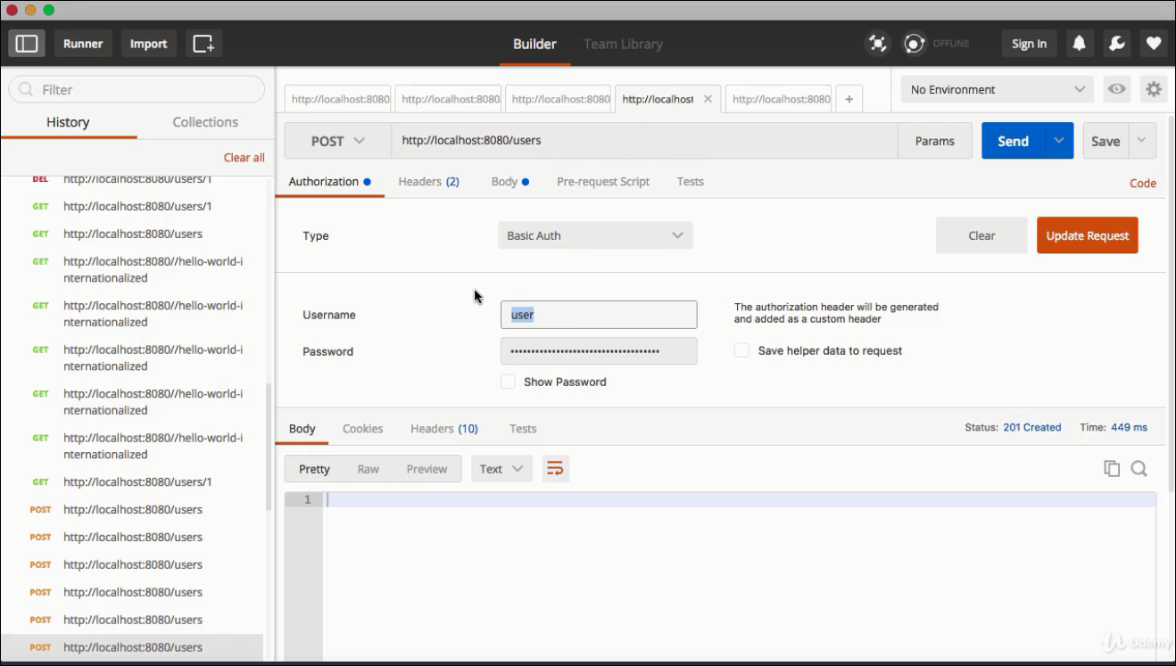

If username/password is not correct or provided :

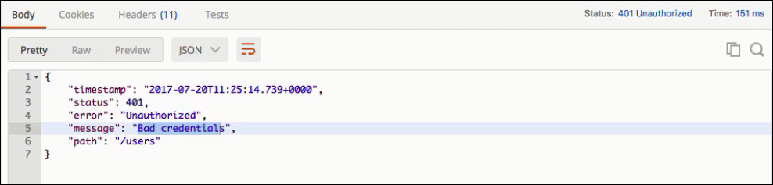

Disadvantage: each time server restarts , the password changes.

Solution : provide the password in the application.properties

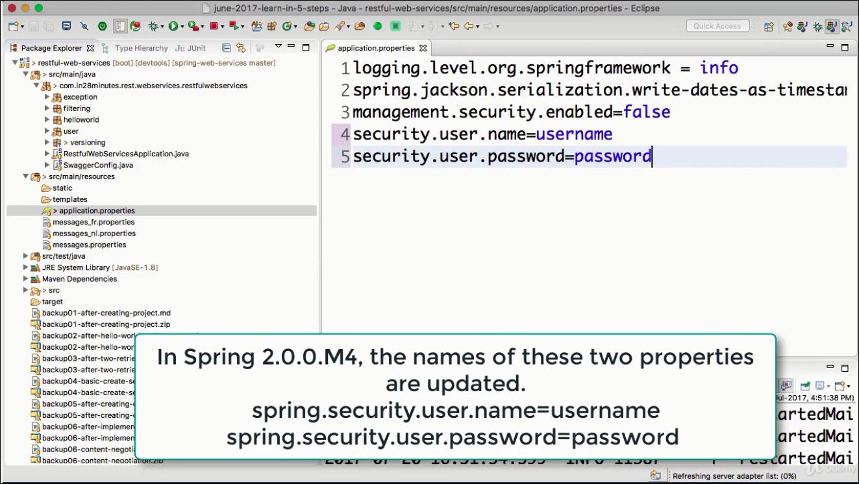

try now with new username/password .It’ll provide u the expected result.